Tyger by SF Said, illustrated by Dave McKean
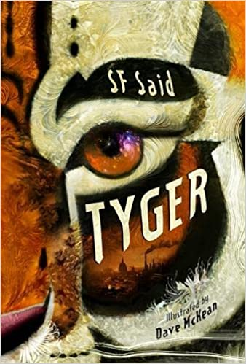
About the book
In a strange alternate world, where the British Empire is still a cruel ruling force, a young boy called Adam has uncovered something incredible in a rubbish dump in London - a mysterious, mythical animal. A TYGER.
The Tyger is in danger, and Adam and his friend Zadie are determined to help. However, they soon realise it isn't just the Tyger's life at stake: the world they live in is also on the precipice of darkness. Luckily, the two children have great powers within them, and the Tyger can show them how to harness what's inside . . . This is story to stretch your thinking and inspire your imagination!
For children aged 9+
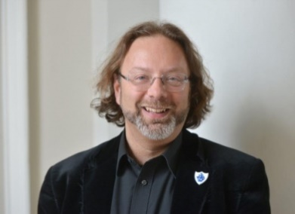
About the author
SF Said was born in Lebanon in 1967 and has lived in London since he was 2 years old. He wrote his first novel Varjak Paw (2003) while working as a speechwriter for the Crown Prince of Jordan, and then as an arts journalist and film programmer. Varjak Paw won the Nestle Smarties Book Prize for Children’s Literature, as well as several other awards, and the sequel The Outlaw Varjak Paw won the BBC’s Blue Peter Book of the Year. He is a Fellow of the Royal Society of Literature, and writes about children’s and young adult fiction for the Guardian and the Daily Telegraph. See his website at www.sfsaid.com
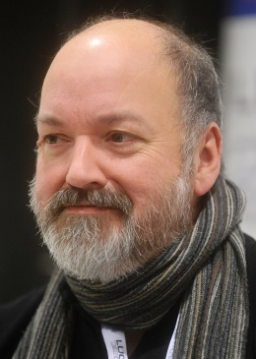
About the illustrator
Dave McKean is an English illustrator, photographer, comic book artist, graphic designer, filmmaker and musician. His work incorporates drawing, painting, photography, collage, found objects, digital art, and sculpture. He has illustrated books by authors including Neil Gaiman, David Almond, Ray Bradbury and Stephen King, and he has directed three feature films. He has a website at www.davemckean.com

Tyger – Reading notes and discussion & activity ideas

Thinking and talking about the book
There’s a lot to think about in this book – and to find out more about!
Here are some book-talk questions to see what your first responses are and what has meant most to you in this story.

- How did you feel when reading this book? And when you’d finished it?
- Which parts of the story do you remember most?
- Did you skip any parts? Which ones?
- Was there anything that took you by surprise?
- Were there any parts you didn’t make sense of?
- What was the thing you most liked finding out from the book?
- What kind of a book did you think it was going to be?
- If you gave up on this book can you say why?
- What would you say about this book if you were telling someone what you’ve just read?
- Does the story work for you? What does the book say to you?
- Has reading the book changed or affected you? At the end of the story did you feel as if you’d shared a real experience?
- Did it get you thinking about some things more – or in a different way?
- Did you stop and start, or did you want to read it all through in one go?
- Are there parts you want to read over again?
- Would you recommend the book to your friends? Why? Or why not?

Tyger Wordsearch
Hidden in the squares below are the names of some of the characters and some of the main things in the story, for you to find, talk about, and look up and find out more about them. Have a look across – forwards and backwards – and up and down.
ADAM TYGER ZADIE GHETTO MENAGERIE
GUARDIANS LIBRARY ARABIAN NIGHTS DOORS
LAMB MIDWINTER NIGHT TYBURN URIZEN
Q | W | M | I | D | W | I | N | T | E | R | N | I | G | H | T
X | G | E | X | V | N | M | B | C | Z | A | S | X | F | X | Z
F | V | N | R | U | B | Y | T | F | L | I | B | R | A | R | Y
S | C | A | B | M | B | W | X | V | A | D | G | E | C | X | M
T | A | G | D | G | X | F | Q | X | M | Q | V | G | B | V | B
H | W | E | E | Q | V | W | R | F | B | P | F | Y | B | J | U
G | G | R | C | H | W | F | S | H | C | F | B | T | Y | P | B
I | U | I | J | K | U | R | I | Z | E | N | C | V | F | X | V
N | V | E | Z | X | B | W | Q | A | Z | U | J | B | C | B | C
N | Q | X | G | M | S | N | F | D | B | J | U | X | O | Z | M
A | D | A | M | D | D | F | S | I | X | T | Z | P | T | X | Z
I | Z | F | X | Z | O | Q | G | E | F | X | Y | Z | T | J | A
B | X | C | K | J | O | X | L | F | V | D | M | Q | E | H | W
A | B | T | X | U | R | L | J | H | X | S | V | C | H | B | Q
R | P | D | X | G | S | N | A | I | D | R | A | U | G | X | R
A | Z | U | S | X | B | M | K | Z | F | D | R | W | V | Z | Y
Tyger: People in the story
Here are some of the main characters in Tyger but the letters in their names have been mixed up. Can you work out who they each are?
1.MAAD LAMBRAHA:
When I was making deliveries for my family’s business I found the Tyger sheltering in a ruined building.
2.DEZIA:
I am named after Scheherazade, the queen who tells stories in The Arabian Nights. I am Adam’s friend and together we are trying to help the Tyger
3.MORETRIM MYDEALHED:
I own a menagerie, and I made a fortune in the slave trade. I am also Urizen.
4.MOONSOL RUTE:
I am Zadie’s father; I am a bookseller and a printer. I am from Timbuktu and was once a slave.
5.DOL CAJK:
I am a shepherd. When the land where I live is enclosed I have nowhere to go.
6.GRYTE:
I smell of the sweet, high scent of honeysuckle growing wild. I am a being of eternity and infinity, who helps Adam and Zadie to make a difference in the world.
7.NAAH:
I am Adam’s little sister and I love it when he does his drawings.
8.RIZAM:
I am Adam’s older brother. I want to find the Tyger so that I can get the reward money for our family.
Here are two more characters – can you tell who they are?
X: I was once a painter. Now I sew and mend clothes – I embroidered an old shirt with golden thread, making the fabric look almost new.
Y: The family calls me Baba. I am afraid of being in debt and losing our shop, our money, maybe our lives.
Things to think about – and to research further
The story of Tyger is set in London in the 21st Century – but it is not the London or the 21st Century which we know today.
It happened in the 21st Century,
when London was still the capital of an Empire,
and the Empire still ruled the world… (pi)
In real history the British Empire, with London as its capital, flourished in the 19th and 20th centuries, ruling or administering territories right across the world, but by 1997 these territories had become independent and the Empire ended.
In Tyger’s alternate 21st century London the British Empire still exists, slavery has not been abolished, immigrants live in ghettos with armed checkpoints, the skies are dark, and travel is basic and unmechanised.
What other differences do you see between Tyger’s London, where Adam, the main character lives, and life in England today?
What has – or hasn’t happened – to make these differences?
And can you find similar things in both Tyger’s 21st century, and the 21st century we live in today?
Find out more about:
- The British Empire. When Adam looks at a globe of the world he sees that...All the lands of the Empire were painted red, so most of the earth was red. (p121)

- Slavery, and the abolition of slavery. My father always says things would be different if slavery had been abolished, and if the Empire had ended. (p174)

- Enclosures: The Enclosure Act. ‘Them that is enclosing the land in fences and walls, to keep the rest of us out.’ (p46) ‘It’s happening, lad…They is taking all the land.’ (p90)

- The Glass Tax. The windows of the back room had been bricked up, to save paying the Glass Tax. (p37)

- Workhouses. ‘Workhouses are places where the poorest people of this land end up.’ (p120) See also p127

- Ossulstone. ‘Much of what we now call London was once called Ossulstone. It was named after a standing stone known as the Ossulstone, which has stood in this city since ancient times.’ (p164)
Also p225.

Adam’s London – and London today
Almost all the buildings and streets mentioned in this story are places in London today. There are a few differences, for example the Ossulstone is no longer by Marble Arch – this ‘St Oswald’s Stone’ disappeared in 1869. And the river Fleet now runs underground.
Get a map of London and find the places listed below. You could draw your own map of London, with the river Thames running across it, and mark each place – and add notes where something special happens in the story.
- Soho (p1)– where Adam lives
- Oxford Street (p3)
- Tottenham Court Road (p4)
- Highgate (p40) ‘It’s miles away, so you’d best set out at dawn. And…be careful.’
- St Pancras Cathedral (p41) …on the banks of the River Fleet. This was actually St Pancras Old Church and was once on the banks of the Fleet.
- River Fleet (p41)
- St Paul’s Cathedral (68) …where many people had gathered in the courtyard, beneath the massive dome.
- Charing Cross Road (p71) …a street on the edge of the Soho Ghetto that was famous for its bookshops.
- Hampstead (p89) …north of London…a village called Hampstead, by the source of the River Fleet
- Leicester Square and Piccadilly Circus (p103)
- Trafalgar Square and Nelson’s Column (p125) …he…gazed at the grand art galleries…
- The Thames (p134) He saw the Thames, like a great thread running through the city, with all its tributaries.
- Big Ben and the Palace of Westminster (p140) By the River Thames…Adam thought those great stone structures must have stood there forever, ruling over the Empire.
- Hyde Park (p141)
- Tyburn (p142) ..prisoners were being executed at Tyburn today…and p247 …they knew that a gateway could be open here…
- Edgware Road (p141)
- London Bridge (p151 & p156) …that great big beautiful bridge, which stood on the spot where a bridge had always stood since Roman times… (170-1)
Tyger Wordsearch solution
Q | W | M | I | D | W | I | N | T | E | R | N | I | G | H | T
X | G | E | X | V | N | M | B | C | Z | A | S | X | F | X | Z
F | V | N | R | U | B | Y | T | F | L | I | B | R | A | R | Y
S | C | A | B | M | B | W | X | V | A | D | G | E | C | X | M
T | A | G | D | G | X | F | Q | X | M | Q | V | G | B | V | B
H | W | E | E | Q | V | W | R | F | B | P | F | Y | B | J | U
G | G | R | C | H | W | F | S | H | C | F | B | T | Y | P | B
I | U | I | J | K | U | R | I | Z | E | N | C | V | F | X | V
N | V | E | Z | X | B | W | Q | A | Z | U | J | B | C | B | C
N | Q | X | G | M | S | N | F | D | B | J | U | X | O | Z | M
A | D | A | M | D | D | F | S | I | X | T | Z | P | T | X | Z
I | Z | F | X | Z | O | Q | G | E | F | X | Y | Z | T | J | A
B | X | C | K | J | O | X | L | F | V | D | M | Q | E | H | W
A | B | T | X | U | R | L | J | H | X | S | V | C | H | B | Q
R | P | D | X | G | S | N | A | I | D | R | A | U | G | X | R
A | Z | U | S | X | B | M | K | Z | F | D | R | W | V | Z | Y

People in the story
- Adam Alhambra
- Zadie
- Mortimer Maldehyde
- Solomon True
- Old Jack
- Tyger
- Hana
- Ramzi
X: Adam’s mother Y: Adam’s father

