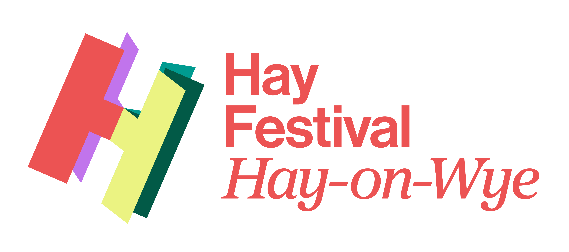
The Platform 2025 - Application Form
The deadline for submissions is 12.00 pm Thursday 3rd April 2025
Before you complete this application form for The Platform 2025, we suggest you read through all the details, together with the FAQs.
For any further queries or questions please contact platform@hayfestival.org
Your Details
1. Full Name

2. Full address including postcode

3. E-mail address

4. Mobile number

5. Please provide a short outline of your proposed project (no more than 500 words).

6. Please provide a CV/biography – including information about your professional experiences (or attach as a separate pdf or word document)

7. Please write a statement outlining your creative ambitions and goals as an artist (no more than 150 words)

8. Please provide any links to your work e.g website, YouTube, social media platforms, Soundcloud , photographs or publications

Consent & GDPR
9. GDPR: Hay Festival are committed to protecting your privacy and data. The personal data you provide in the completion of this application form will be used by Hay Festival to administer your application in accordance with GDPR. This data will be retained for the duration of the application process and for a reasonable time for reporting and evaluation.

Do you consent to Hay Festival storing and using the data provided in this way? Please indicate with an X:
Yes No

10. Hay Festival would like to send you information about its events, opportunities, and products by email. You may remove your consent to receive Hay Festival information about its events, services, and products at any time. To view your personal data held by Hay Festival please contact us.
Do you consent? Please indicate with an X:
Yes No

12. Where did you hear about this opportunity?

Return this completed form to platform@hayfestival.org

The Platform is supported by:

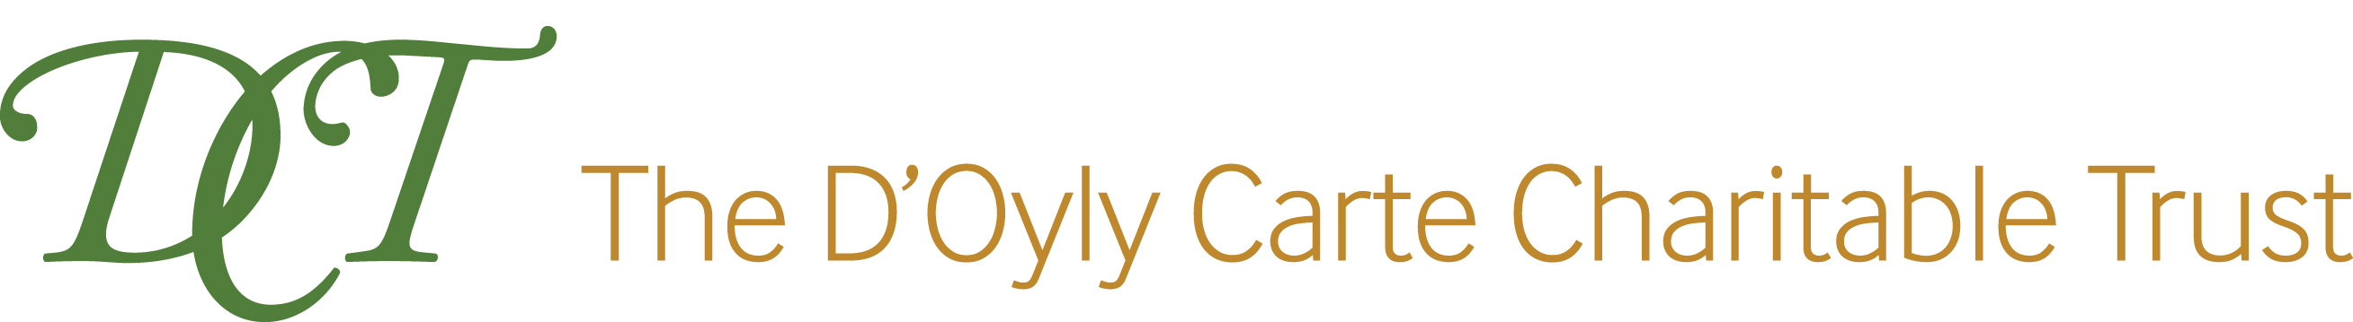
The Martin Smith Foundation

